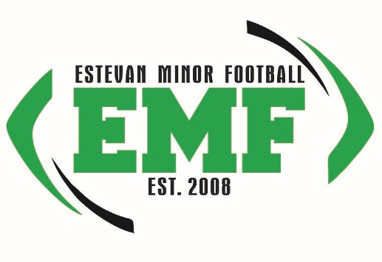
Estevan Minor Football Coaches Application
Please return to emfmort@gmail.com when completed
Applicants Name: |  | E-mail Address:
Address: |  | Cell Phone:
City/Prov |  | Work Phone:
Area Code: |  | Home Phone:

Please check division of interest:
Atom_______ Pee Wee________ Bantam_______ Female Team______ Flag Football_____

Please mark (x) beside every positional coach job you’d be interested in:
Head Coach___ Offence Coordinator___ Defense Coordinator___
Offence line___ Wide Receivers___ Quarterbacks___
Running Backs___ Defense Line___ Linebackers___
Defensive Backs/Safety___ Special Teams Coach___ Trainer___ Manager___

Do You Have Children Playing?
Child’s Name |  | Child’s Team |  | Date of Birth
Child’s Name |  | Child’s Team |  | Date of Birth

Coaching or Youth Related Certifications :
Organization: |  | Date Obtained:

Organization: |  | Date Obtained:

Organization: |  | Date Obtained:

Coaching Experience:
Organization |  | Team |  | Position |  | From Date to Date
Organization |  | Team |  | Position |  | From Date to Date
Organization |  | Team |  | Position |  | From Date to Date
Organization |  | Team |  | Position |  | From Date to Date

How would you describe yourself as a youth sports coach? What is your coaching philosophy?
(winning, having fun, discipline, team work, etc…)

Describe your previous work with children:

Please list other skills, playing experience, or other experiences which qualify you as a youth coach:

Have you ever been formally disciplined from a youth sports program either as a coach, parent, or observer? If so, please explain the disciplinary action, organization, and date.

All coaches applications are held in strictest confidentiality with the Estevan Minor Football Organization
All coaches will require a Criminal Record Check (available at Estevan Police Service or RCMP detachment)
All applicants will be notified for interview with Estevan Minor Football Coaches Committee
2019 Estevan Coaches Committee:
Kevin Mortenson 1-306-421-3377
Pat Ford 1-306-421-9233
Bill Paulson 1-306-421-7861

